**Name of Student __Yixin Wang__________________ Score ________________**

**Student Number ___yw326_______________________ Date ______2020/10/10________**

**EE 188L Lab 4: Node-Voltage & Mesh-Current Analysis**

**EE 188L Electrical Engineering I**

NAU + CQUPT (Fall 2020)

**Summary**

The purpose of this lab is first to show with measurements that **Kirchhoff’s Current Law** (**KCL**) and **Kirchhoff’s Voltage Law (KVL**) can be used to analyze a circuit by writing **Nodal & Mesh Equations**. The measurements of currents **leaving** each node will add to **zero** as required by **KCL**. The student will then treat the measured voltages (with respect to the reference node) as unknowns, and solve for those voltages by Node-Voltage or (Nodal Analysis) Method. Measured and calculated voltages will be compared.

Also, mesh-current equations will be written around the 3 meshes in the circuit using the measured resistances. The simultaneous equations formed will be solved in Excel to derive individual mesh currents. These will then be compared to actual measured branch currents.

1. **Test bench equipment**

**Dual DC Power Supply:**

The **Dual DC PS** has **two** **independent** ideal voltage sources that can provide voltages at the same time: 0 to+15VDC and 0 to -15VDC. For this experiment, **both** power supplies are used at the same time. The method to produce a **+5VDC** will be explained by the **Instructor**.

**Digital Multimeter (DMM):** The DMM is capable of **measuring resistances**, **voltages** and **currents**. The **DMM** measurement procedures will be discussed by the **Instructor**.

1. **Measuring Resistance**

Locate 5 resistors with the values given below; **measure** the **actual resistance** with the **DMM** in **Resistance mode**. Record the **actual values** to 2 decimal places (for example if R2 measures=> 2.7132k, use 2.71k):

**R1 = 3.9k => _3.794kΩ______________________(measured)**

**R2 = 6.2k => _6.215 kΩ______________________(measured)**

**R3 = 1.3k => _1.275 kΩ______________________(measured)**

**R4 = 2.7k => _2.707 kΩ______________________(measured)**

**R5 = 2k => ___2.003 kΩ____________________(measured)**

1. **Circuit**

On the **BB** put resistors **R1, R2, R3, R4, R5** and the **two Power Supplies (PS)** as shown in the schematic below. **Note: Make the two PS independent as explained by the Instructor.**



Adjust the PS **voltage**, **V1**, of the **PS** to **V1 = +12V** with respect to its own reference. **🡪 Measure with the DMM to be sure!**

Adjust the PS **voltage**, **V2**, of the **PS** to **V2 = +5V** with respect to its own **reversed** **reference**, by **using the black as the + reference** and the **red as the – reference. 🡪 Measure with the DMM to be sure!**

1. **KCL and Node-Voltage Analysis**

Choose node C for nodal voltages’ reference zero.

Measure and record voltages VA (at node A) and VB (at node B) with respect to reference zero at node C.

**VA = _____5.206V__________________________**(measured)

**VB = _____3.948V__________________________**(measured**)**

At **node A measure and record** the **currents leaving the node**.

* **Listen to the Instructor’s explanation on how to connect the DMM in series in a circuit to measure current.**

**ILeftA = ____1.799mA__________________________**

**IRightA = _____-0.953mA________________________**

**IDownA = _____-0.845mA________________________**

**ITotalNodeA = ILeft + IRight + IDown = ___0.001mA________** (Should be close to 0)

At **node B measure and record** the **currents leaving the node**.

**ILeftB = _____-0.953mA_________________________**

**IRightB = _____-0.505mA________________________**

**IDownB = ______1.459mA_______________________**

**ITotalNodeB = ILeft + IRight + IDown = ____0.05mA_______** (Should be close to 0)

**Nodal Analysis:**

Set-up the **Nodal Equations** by treating **VA, VB** as **unknowns** and applying **KCL** at **nodes** **A, B**.

Node-voltage equations:

Node A

(12-VA)/3900=VA/6200+(VA-VB)/1300

3692VA-2418VB=9672

Node B

(VA-VB)/13=(VB-5)/20+VB/27

540VA-1151VB=-1755

**NOTE: Use the measured values of R1, R2, R3, R4, R5, NOT the listed values when setting up the equations!**

**VA = _______5.22V________________________**(calculated)

**VB = ________3.98V_______________________**(calculated**)**

**Compare** the **calculated values** to the **measured values**.

(They should be pretty close!)

1. **Questions and Mesh-current analysis**
2. **Node-Voltage analysis** is a very powerful method to analyze circuits by generating **independent** equations. The **measured currents** leaving each node must add up to zero. **Why?**

**Because of the KCL,** **The current flowing into a node is the same as that flowing out of a node.**

1. We also have learned in class how to solve circuits with **Mesh Current analysis** by generating **independent** equations using **KVL**. Next, solvethis circuit by **mesh analysis**.

* First, Form 3 meshes & generate equations for ***i1, i2, & i3.***
* **NOTE: Use the measured values of R1, R2, R3, R4, R5 NOT the listed values when setting up the equations!**



Mesh-current equations:

Mesh 1:

12=3900i1+6200i1-6200i2

11100i1-6200i2=12

Mesh 2:

6200(i1-i2)=1300i2+2700(i2-i3)

62i1-102i2+27i3=0

Mesh 3:

(i2-i3)2700=2000i3+5

2700i2-4700i3=5

* Solve for *i1, i2, & i3* using Excel
* Use Excel’s MMULT & MINVERSE formulas or Matlab to solve the simultaneous equations.
* Show your Excel or Matlab printout!
* Write ***i1 = ­­­­­­­­­­­__0.00174A__ i2 = __0.0009A_ i3 = __-0.000598A***
* **Does *(i1 – i2) \**R2 = __5.208V_______ = VA** from the **Nodal Analysis?**
* **Does *(i2 – i3) \**R4 = __4.04V_______ = VB** from the **Nodal Analysis?**

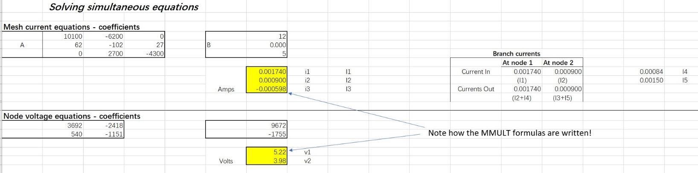

**Important: Get the lab instructor’s signature & date below, no signature means no marks!**

Signature of instructor ____________________ Date: ____________

